## Merchant

Demo date: Oct 24, 2024  
Scoping start date: Oct 17, 2024

MSA Signature Date: Dec 18, 2024  
Onboarding Kick Off Date: Dec 23, 2024

[If Exists] Opt Out Date: June 1  
Go Live Date: Mar 28, 2025

GTM POC: Sean  
Implementation POC: Jeff Royce

ERP: NS

Tax Integration: No Tax

### 

### Key people at Merchant

| [Amir Bakhshi](https://www.linkedin.com/sales/lead/ACwAACllWXgBf6mzzslcVZaNWcW7OTM7GZpKFUE,NAME_SEARCH,NqgV?_ntb=zZ%2BYJOQ0TwKMJ8mMJqgGdA%3D%3D&lipi=urn%3Ali%3Apage%3Ad_sales2_search_people%3Bf%2Bk6Cz42RUyfkLXdf3IoaA%3D%3D&licu=urn%3Ali%3Acontrol%3Ad_sales2_search_people-view_lead_panel_via_search_lead_name&snfl=NoYVzmQQTsC%2FHMwf5thifg%3D%3D) | Program Manager |
| --- | --- |
| [Mason Hanson](https://www.linkedin.com/sales/lead/ACwAAAv7KfsBqMU8Qs5J8QqJ4MM0dMiWfNuxz-k,NAME_SEARCH,hFET?_ntb=hlw67MCBQtKcu4UVsTmufg%3D%3D&lipi=urn%3Ali%3Apage%3Ad_sales2_search_people%3BqkGEIQVmTxKE8wwlAsOatw%3D%3D&licu=urn%3Ali%3Acontrol%3Ad_sales2_search_people-view_lead_panel_via_search_lead_name&lici=K%C3%8B%C3%A2%C2%81c%C3%BCDx%C2%8A%C3%A6%C3%B8d%14%C2%83q%C2%95&snfl=1swdbOU9Q6yYN%2FUPRZncAg%3D%3D) | Head of Business Operations |
| [Rajesh Rao](https://www.linkedin.com/sales/lead/ACwAAAAxPg8B5XNYXk4ePyY43_k-E7QzqAZocNU,NAME_SEARCH,D8xe?_ntb=05C0Jo9vT7yt%2FrSPgrKqcg%3D%3D&lipi=urn%3Ali%3Apage%3Ad_sales2_search_people%3B%2BxyS%2Bq22QLKgSnkCglqWRw%3D%3D&licu=urn%3Ali%3Acontrol%3Ad_sales2_search_people-view_lead_panel_via_search_lead_name&lici=%C3%AD%C3%85%0E%C2%AE-%C2%ABNZ%C2%B92x%1A%5C%C3%ABf%C2%AF&snfl=8XsFp54RTz%2BgifYydmPKuw%3D%3D) | CFO |
| [Brian Preti](https://www.linkedin.com/sales/lead/ACwAAAA5bfgBbgnAkFMvUfTpkAsRfcO2esg6I2M,NAME_SEARCH,1_I-?_ntb=%2FMto7TkzQJaHF7qhAjkdNQ%3D%3D&lipi=urn%3Ali%3Apage%3Ad_sales2_search_people%3BDiyTepRRTtCR6Ay9qfOYDA%3D%3D&licu=urn%3Ali%3Acontrol%3Ad_sales2_search_people-view_lead_panel_via_search_lead_name&lici=R%C2%A8%2BKX%C2%A3O%C3%A1%C2%BB%C2%B1%12%C2%AF58%C3%91%04&snfl=10AYhl%2FLTIirVzrbNEiC7g%3D%3D) | Controller (new) - 4 months | Future state |
| Jeremy Bowyer | Data analyst (usage data) |
| [Michael Martel](https://www.linkedin.com/sales/lead/ACwAAAnP7ZUBTZLtNt0YRQUeQx4qPhUMiajAO1I,NAME_SEARCH,X3p9?_ntb=RDaJWvBUTw%2BzXndqmuKx6A%3D%3D&lipi=urn%3Ali%3Apage%3Ad_sales2_search_people%3Btbjhd0rnQw21trnm5l6uJA%3D%3D&licu=urn%3Ali%3Acontrol%3Ad_sales2_search_people-view_lead_panel_via_search_lead_name&lici=%26nM%C2%A7%C3%9C%26I8%C2%AF%7B%24%C3%83%C3%B2%C2%AC%C2%92%C2%BA&snfl=3ZpzbcrJSBSfMm%2FKHUfuow%3D%3D) | Sr. Manager Rev Ops - between SF CPQ - custom billing on the contracts and SF integrations side |
| [Prafulla Patil](https://www.linkedin.com/in/prafulla--patil/) | Title ? - Data analytics/systems integrations |
| [Jeri C](https://www.linkedin.com/sales/lead/ACwAAAeZCQQBFJGmNrh23I2-CwTQV4U_nl537bs,NAME_SEARCH,u-hV?_ntb=q%2FLUur3STEeiZhlFBpZALQ%3D%3D&lipi=urn%3Ali%3Apage%3Ad_sales2_search_people%3B6urihKSLTwapSadZMp1FYA%3D%3D&licu=urn%3Ali%3Acontrol%3Ad_sales2_search_people-view_lead_panel_via_search_lead_name&snfl=THQ0S7SRRkSWPudv4JqKOg%3D%3D)ryderman | Accounting Manager |
| tenneva.wassman | AM - Sr accountant |

| Notes Sections [Ops International Team to Ignore] *(AE/ Implementation to fill)*   * Info on how merchant bills   + Bills usage in arrears   + Platform fees * Is there any important merchant relationship information?  1) What is the merchant temperament? - incredible they love us   2) Is there a key POC: (i.e.: who is the buyer/decision maker?)  Mason and Brian 3) What are the Tabs features that the key POC cares about?  Multi service invoicing with usage based and flat software fee components  Tier based discounts  Invoice Split Scenarios   * Parent child architecture to bill to multiple cost centers   Invoice Audit Process  Government milestone based invoicing  **Roadmap** (they dont know its roadmap, they think we do this already but that we will need to customize it to them):   * + Commitment   + Consumption tracking   + Minimum true ups   + SKU with/without commits   + CSV export for revenue rec   + Usage ingest |
| --- |

### 

### Company summary *(AE to fill)*

Translation services

Goals (North star)  
*(AE/ Implementation to fill)*

What is the merchant's goal? What pain are we solving? Why are they buying Tabs?

Currently the process is very manual and only one person understands/can process it. Need wider functionality to the team

Is there an opt out clause? If so, what is the merchant looking for so they do not exercise it?

Yes, they need to be fully implemented and see the features we promised

### Billing model *(AE/ Implementation to fill)*

Are there unique things about the customer creation process for this merchant?

Yes, they will need two accounts - one for here one for ireland

Information on how merchant bills

How contract is broken up

One off things to know about the merchant

Usage API

SF integration

### 

### Customer Assignment

* DO NOT CREATE CUSTOMERS for Lilt. If they do not exist, please flag
* Lilt will upload the same contract to both *Lilt, Inc.* and *Lilt Technologies* instance. However, the contract should only be processed in one of those instances.
* To determine what the correct instance is, look at the top left corner of the contract

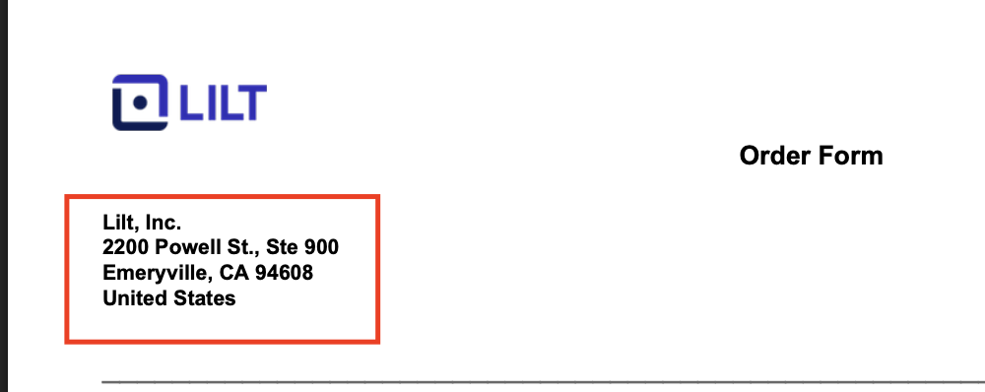 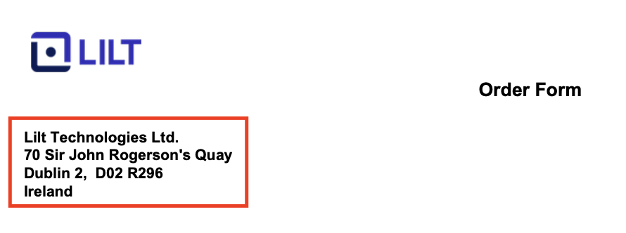

* + If it’s in the correct instance (i.e. Lilt, Inc. is in Lilt, Inc.) process
  + If it is NOT in the correct instance (i.e. Lilt, Inc. in Lilt Technologies) please DELETE
    - Before deleting!
      * ***check to see if it was deleted in the other instance. If it was deleted and you think it shouldn’t have been, create a ticket before you delete yours
        + We will need to reupload to the correct instance
      * Contracts shouldn’t be deleted in both instances EVER
* Other things to note for Customers:
  + When assigning the Customer
    - If the customer names aren’t exact or close to exact (for example, there are many different Philips customers in both instances) -> look at the customer address in garage, it should match the customer address in the contract.
      * If the address doesn’t match and you still aren’t sure - create a ticket
* Specific Customer Info and Mappings
  + *Snap* is not being billed through Tabs given the complex billing requirements -> If you see any Snap contracts, mark as processed no BTs
  + Specific Customer Mappings
    - If you see the customer Jabra or GN Store Nord A/S, paste this customer ID into the customer field: bfa7fa33-5b30-4094-a1e4-12c10cc6e732
    - If you see the customer: [Brandwatch 1st Floor, Sovereign House, Church Street Brighton, BN1 1RA United Kingdom]
      * Assign the customer [Brandwatch - Runtime Collective Limited Sucursal en Espana]
    - If you see the customer Anixter, it should be Wesco
    - If you see the customer: [ALPHA INTERNATIONAL USA IP, LLC 3350 Riverwood Parkway SE, Suite 670, Atlanta Georgia, 30339 United States]
      * Assign the customer [AI USA] (Paste this customer ID into the customer search bar: 2cce45ca-dcfc-45a4-8f27-c47fa6ae255d)

### 

### Contract Processing Steps

**General**

* Examples of Flat vs. Usage BTs in screenshots below

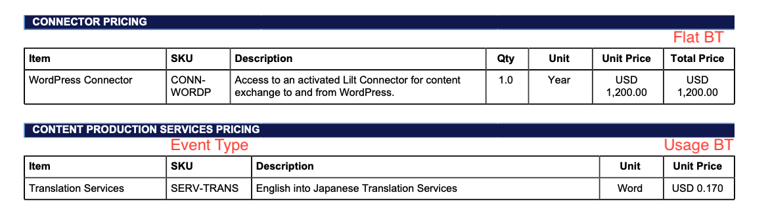

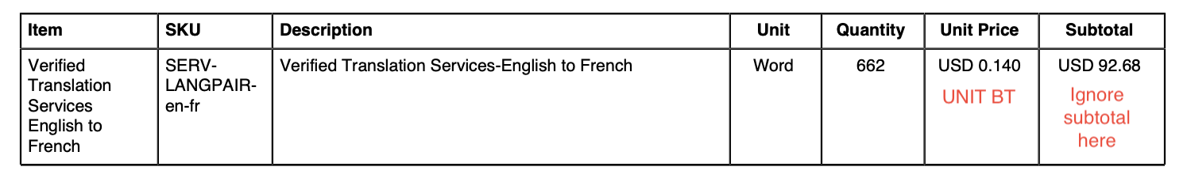

* Explanations for some of the nuances in the above screenshots + why we ignore the “Subtotal” column
  + The first BT is flat because it is a SKU providing access to a connector for a year and has a “Total Price” column. Using best judgement, we can reason that this functions like an subscription
  + The third BT is usage because its unit is a word and they are charged for every translation. Using best judgement, we can reason that this will only be charged for individual actions, so it should be a usage BT.
    - For Usage BTs like this that have a Unit Price column, we should ignore the Subtotal column
* Every contract will need to have an Offline Usage BT. It will be set up using the below instructions
  + Service start date and billing start date:
    - same as the rest of the usage BTs
    - If no usage BTs on the contract, use the first of the month that the contract start date is in
  + Months of service: match the other BTs
  + Unit price -> $1 price -> event to track “Offline”
  + Integration item: SERV-TRANS-OFFLINE
  + # of periods + frequency:
    - match the usage BTs
    - If no usage BTs, use the contract length + billing frequency (monthly or semi-monthly)
  + Net terms: match the other BTs
  + Billing time: last of period

**Processing Flat BTs**

* Flat BTs will mostly be items that have a total price column populated.
  + However, there will also be Flat BTs with no total price column but the unit will be Annual/Year or the description will detail services that can be judged as a one time payment (meaning you cannot easily determine what a usage event would be).
    - Please see the additional examples below under **Additional examples of flat billing terms**.
* Use total price as the total price
* Use additional terms section to find service start date, months of service, billing start date, and # of periods
  + **Exception:** if the contract date falls in a closed period, move the start date to the first month outside of the closed period.
    - For example, if the books are closed through January, make the start date Feb 1 for the BTs
* Use quantity column for quantity
* Use item column for item name
* Description:
  + First: Put the SKU
  + Second: Put the description column
  + For example: “LILT-PLATFORM - Includes access to: Performance Analytics, Workflow Management, Linguistic Data Storage and Management, Fine-tuning/Model Builder/3rd party integrations”
* Frequency:
  + For Annual / 1 year flat BTs, use YEAR.
  + If the unit column was 2 years for the flat BT, the frequency would be 2 YEAR(S).
    - This is true regardless of what the “Invoice Terms” section says UNLESS it explicitly mentions a flat BTs section (see screenshot in **Exception** section).
    - So… even if the “Invoice Terms” section says the invoicing cadence is semi-monthly or monthly, we would ignore this for flat BTs and should stick to the upfront payment with 1 year frequency if that’s what was listed.
    - If for a flat BT, there is no mention of annual in unit or of a specific frequency in the additional terms section, you can default to NONE.
  + *To reiterate*, FLAT BTs will NOT follow the Invoice Terms section UNLESS it explicitly calls out the flat Billing Term.
    - This means that we shouldn’t be making flat BTs semi-monthly or monthly
  + **Exception:** Make sure to check the “Additional Terms” section.
    - If it specifies a different invoice cadence for a flat BT section, follow that instead.
  + 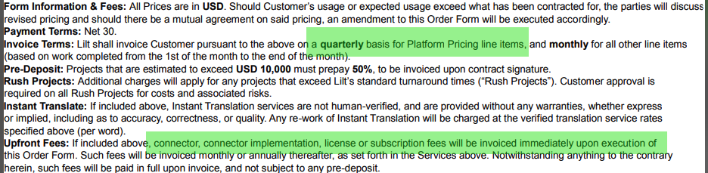
    - “Lilt shall invoice Customer pursuant to the above on a quarterly basis for *Platform Pricing* line items”
      * Even the Flat BTs in the Platform Pricing section said Annual / Year, *we would ignore* and put the frequency as quarterly
    - Also… make sure to check the “Upfront Fees” section says, if available. It can have additional information on billing frequency.
    - When determining what BTs correspond to are being referenced in the additional terms sections, be sure to check section headers.
      * + For example, things referencing “connector” in additional terms will correspond to BTs in the “Connector Pricing” header below.

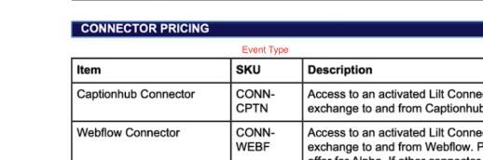

* Integration Item:
  + Use the SKU
    - Many of the integration items will look long, but you should be able to type in the SKU exactly and it will start with that exact SKU
      * For example: the BT with SKU “CONN-NS” will use the integration item “CONN-NS: NewStore Connector”
  + If you can’t find the exact SKU, find the closest thing
    - Look for SKUs that are similar (i.e. SERV-DTP vs. SERV-DTP-HR
    - However, if there isn’t a close match that isn’t an inactive item, *leave blank*
  + DO NOT use items that have “Inactive” in them
* Check additional terms for net payment terms
* **Additional examples of flat billing terms** for reference:
  + 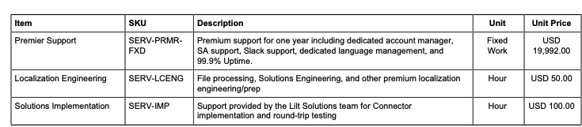
  + 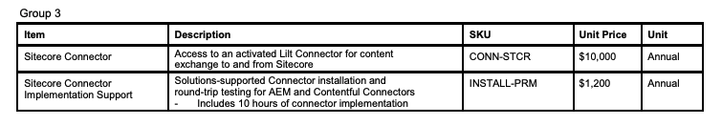

**Processing Usage BTs**

* Use item column as the item name.
* Use the Description column as the item description.
  1. **Exception:** for Translation Services (“Fuzzy Bands”; screenshot below), the description will be the column header.
     1. For example, in the screenshot below, for the Exact 101 BT, the item description would be “Exact 101”.
     2. For the Fuzzy 95-99 BT, the item description would be “Fuzzy 95-99”.

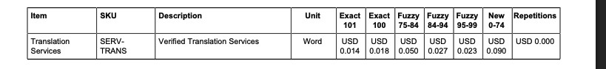

* Usage Event will be the SKU.
  1. **Exception:** for the Fuzzy Band BTs. See below for instructions.
  2. **Exception:** Project Management or Premier Support. See below for instructions.
  3. ***Please pay attention to SERV-TRANS-1 and SERV-TRANS-2, etc.. These are unique events and must be selected if they are listed
     1. This means it should be “SERV-TRANS-1-101” for Exact 101 fuzzy band BT
* Integration Item:
  1. Use the SKU
     1. Many of the integration items will look long, but you should be able to type in the SKU exactly and it will start with that exact SKU
        1. For example, all BTs with “SERV-TRANS” will have the integration item “SERV-TRANS: Verified Translation”
  2. If you can’t find the exact SKU, find the closest thing
  3. DO NOT use items that have “Inactive” in them
* Use unit price for total price.
* **For all usage BTs, set the billing date to the FIRST of the month**
* **For all usage BTs, select “LAST OF PERIOD” for billing timing**
* Use additional terms section to find service start date, months of service, and # of periods
  1. **Exception:** if the contract date falls in a closed period, move the start date to the first month outside of the closed period.
     1. For example, if books are closed through Jan, make the start date Feb 1 for the BTs
* For any BTs titled Project Management or Premier Support or anything similar with a % of project estimate unit:
  1. **Make it a UNIT BT with a total price $1 *no matter what the listed price is***
  2. The event will be the SKU
  3. Use the individual SKU
     1. **\*\*\*Exception**: for “Project Management”, *use* ***SERV-PRMR*** *as the EVENT* and SERV-PRJCT as the INTEGRATION Item
     2. You should *never* use SERV-PRJCT as an event or integration item for any BTs
  4. For contracts with Premier Support (SERV-PR`MR) AND Project Management
     1. We need to track which customers have SERV-PRMR and Project Management in [this google sheet](https://docs.google.com/spreadsheets/d/11kHQIzpFk6ooO7EvXoeQHsYAWnFHAUF8D947RKVpds8/edit?usp=sharing)
        1. Open the “**Customers with SERV-PRMR”** sheet and add the Customer ID, Customer Name, SERV-PRMR % as a decimal, and the Merchant name
           1. Make sure it’s a decimal
        2. After you add it to the spreadsheet, please go to this slack channel **#lilt-processing-workflows** and notify
  5. All of the below BTs in the screenshot apply to this.

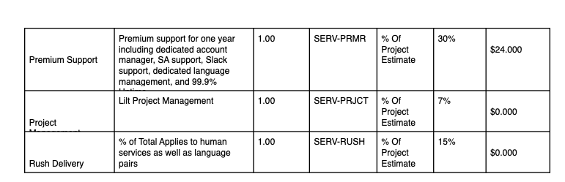

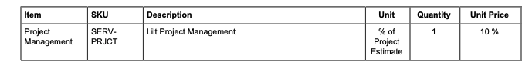

* Instructions for contracts with “Fuzzy Bands” (screenshots below)
* Each individual column with a price will be its own BT. In the below red screenshot, there will be 7 BTs



* + The event for each BT will be the SKU + “-” + the number in the price column.
  + For example: for the first “Exact 101” column, the BT will have a price of $0.14 per unit and the event will be “SERV-TRANS-101.”
  + You still need to create BTs if they are $0 (“Repetitions”)
  + **Exceptions for event type rules:**
    - For Fuzzy 84-94 column, the event will be “SERV-TRANS**-85-94**” NOT **84-94.** This is true for all 84-94 fuzzy bands. The event will need to use 85-94.
    - For the “Repetitions” column, use the SKU + “-” + “Repetitions”. Would be “SERV-TRANS-Repetitions” here.
    - For the “New 0-74” column, the event will be SKU + “-” + “New Words”. Would be “SERV-TRANS-New Words” here.
* Sometimes there are usage BTs (screenshot below) that have a total price and a unit price with qty - treat these as Usage BTs

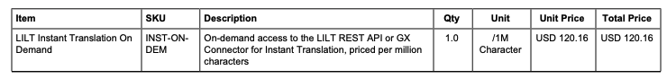

* **If you see Prepaid Reserved Capacity or Reserved Capacity (NEEDS Usage AI)**
  1. If PREPAID Reserved Capacity, first make a FLAT BT for the amount upfront
  2. If regular Reserved Capacity (no Prepaid), you don’t need to make a BT
  3. If you see only one type of Reserved Capacity
     1. Select Usage AI -> “Has usage requirements”
     2. If PREPAID Reserved Capacity, select “Has Threshold”
     3. If normal Reserved Capacity, select “Has Minimum”
     4. Threshold/Minimum amount will be the amount listed in the contract under total price
     5. Select “Full service term” for Threshold/Minimum Period
     6. Make sure integration item matches the correct type of capacity
        1. “Prepaid Reserved Capacity” or “Reserved Capacity”
     7. Select either “Charges Overages” and “True up to meet minimum”
  4. If you see BOTH Prepaid Reserved Capacity and regular Reserved Capacity
     1. Select Usage AI -> “Has usage requirements” AND “Apply usage model sequentially”
     2. *START with Prepaid Reserved Capacity* and then you can add Reserved Capacity
     3. Create the correct models using the above instructions for each respectively
     4. It should first be “Has Threshold” and then “Has Minimum”
     5. Make sure the correct amounts are used for each
     6. Make sure “Charges Overages” and “True up to meet minimum” are selected
     7. It should look something like the below screenshot:

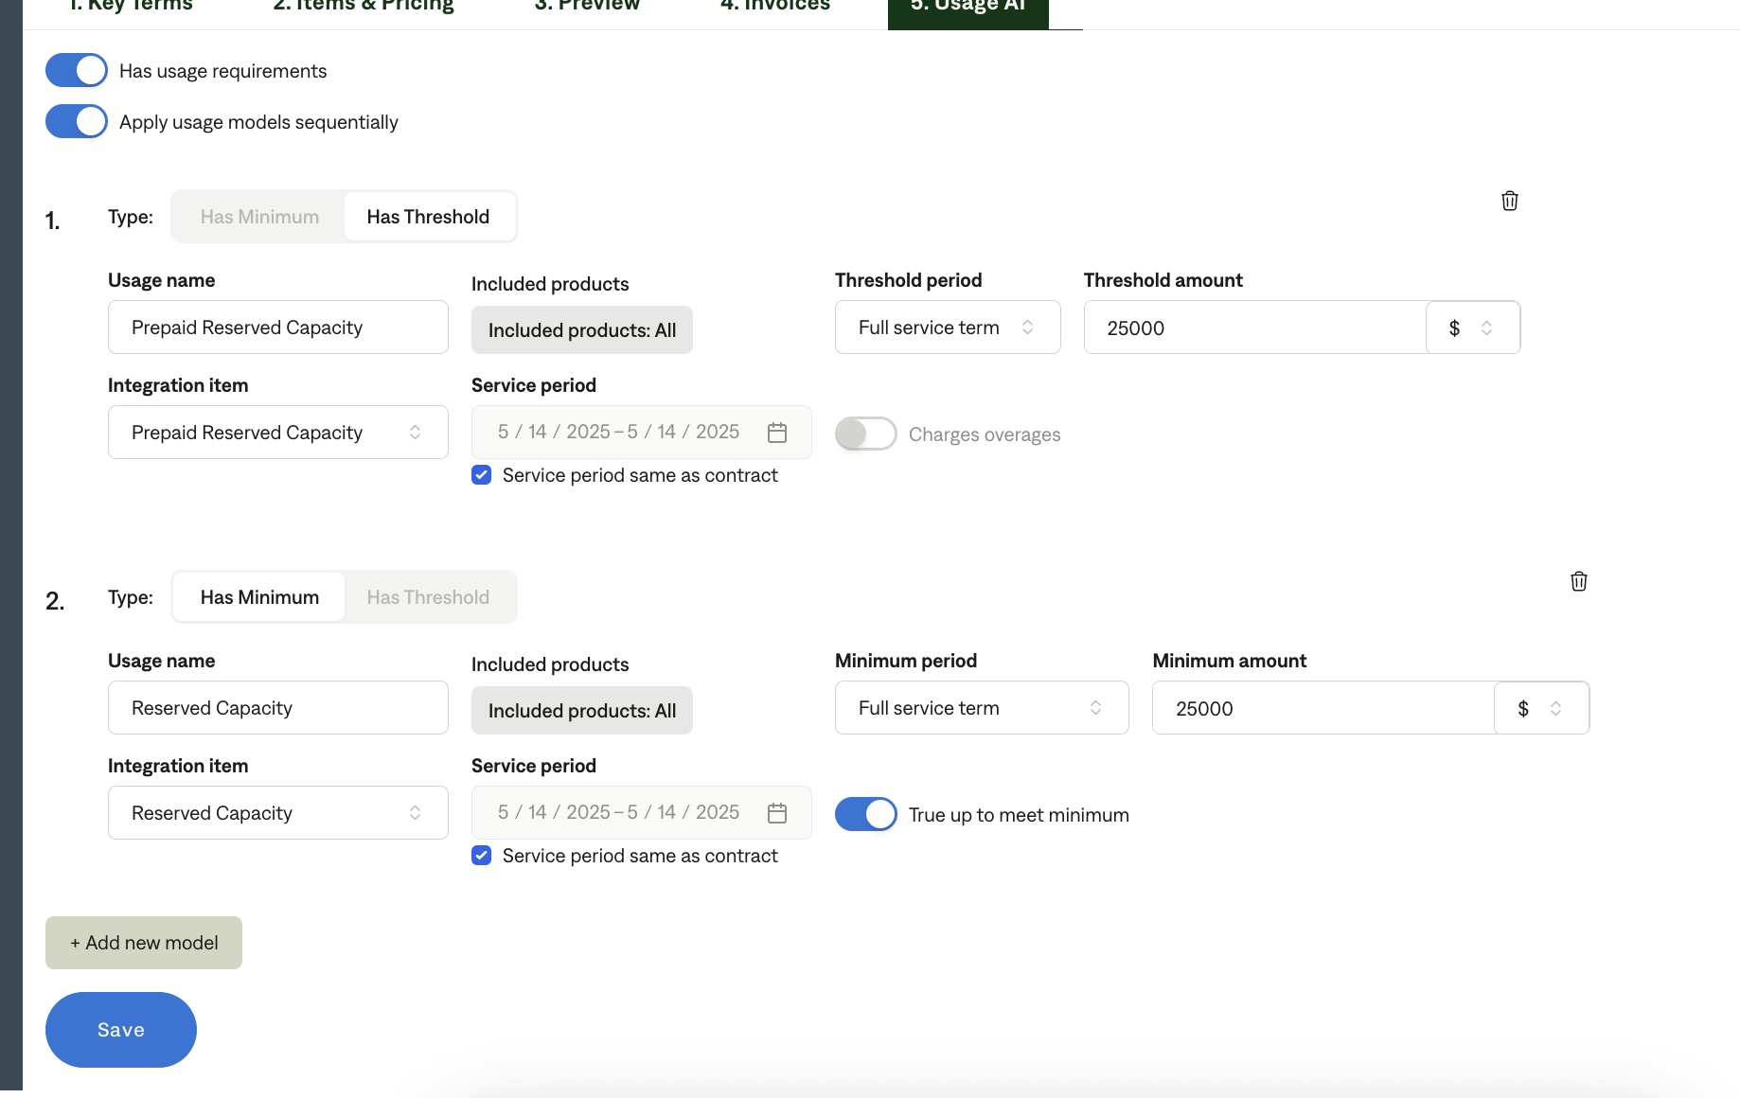

* 1. Examples
     1. [Visa](https://garage.tabsplatform.com/prod/contracts/2dc153fa-6ec4-44ad-8c79-f20673d83cbb/usage) (has BOTH prepaid and reserved capacity)
  2. AFTER you have processed the contract with Prepaid Reserved Capacity or Reserved Capacity, ***you need to add info to a google sheet***
     1. [This is the sheet](https://docs.google.com/spreadsheets/d/1pI02MgXwPT75r5JdE2_KjItkrenPDemKHorjeWi_DVw/edit?usp=sharing)
     2. We need to track all of the contracts that have both reserved capacity and prepaid reserved
     3. Go to the “**PREPAID Reserve Capacity Customers”** or “**Reserve Capacity Customers”** sheet or both depending on what the customer has
        1. In the correct tab in the next row, add the Customer ID, the Customer Name and the amount of Reserved Capacity and/or Prepaid Reserved Capacity
           1. If they have both PRC and RC, you will need to enter the correct amount for each on each sheet
* **\*\*\*Anything to IGNORE in contracts?**
  1. Ignore any BTs under the “AI Package” section
  2. Do not process any BTs under the section “ADDITIONAL OPTIONAL LICENSING AND SERVICES”
  3. If there are multiple options for the same BT in a contract ([example](https://garage.tabsplatform.com/prod/contracts/8c4fa15b-fef2-4f03-91dc-302711661904/terms/key)), do not process any of the “Options”, just process the default / “baseline” amount for the BTs.
     1. For this example, we would only process the BTs under initial term base year column.
  4. Ignore any BTs with the below SKUs
     1. INST-CL-OVER
     2. INST-CL-SUB
     3. MT-BULK-CL
     4. MT-BULK-OP SKUs
  5. Ignore any SKUs where the item has multiple monthly volume columns like the below

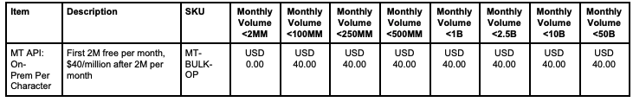

* 1. Ignore any contracts not on Lilt paper -> Process no BTs
     1. “Not on Lilt Paper” means the document is in a format that isn’t coming from Lilt or is a format you do not recognize at all
  2. If you see subtotals in fuzzy band BTs like the below - ignore the subtotal and just process as the usage BTs

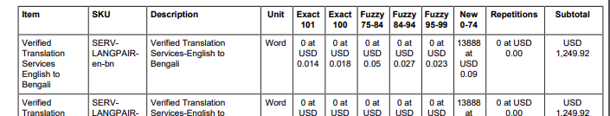

* **Overlapping BTs**
  + Lilt will often send contracts that might overlap with previous contracts that were processed
  + Before you are finished processing, check that there are no overlapping BTs for that customer
  + How to check this
    - Paste the customer ID in garage and sort for processed contracts
    - Look at the contracts with BTs, check the Preview section in garage
      * If the date ranges for those BTs overlap with the BTs you processed for the new contract, please flag
      * Continue processing the contract but make sure that the team is aware

Post Processing Communications (if necessary)  
*(Implementation/Success to fill)*

* Does the Ops Team need to notify anyone on the team re: completion of processing batches in Implementation or Active phase?
* Who needs to be notified and when?
  + Example:
    - Who: Customer Success [Azmat Aziz] needs to be notified
    - Where: Messari internal merchant channel
    - When: contracts are processed [Merchant Phase: Active]

### Customer Information *(Implementation/Success to fill)*

* Any important information on specifics customers of this merchant
  + Special memo’s certain invoices require
  + Invoice changes due to merchant/customer relationship

### Feature Requests *(AE/Implementation/Success to fill)*

* FR 1
  + What is it
  + Why it's important
  + Urgency

### Rewatch Calls *(AE/Implementation/Success to fill)*

* Rewatch by dates